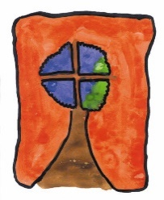
ST. PATRICK’S NATIONAL SCHOOL Phone: 01 2875684

Church Road, Email: admin@stpns.ie

Greystones, Website: www.stpns.ie

Co Wicklow.

A63 EY42 Roll: 12554M

Healthy Eating Policy

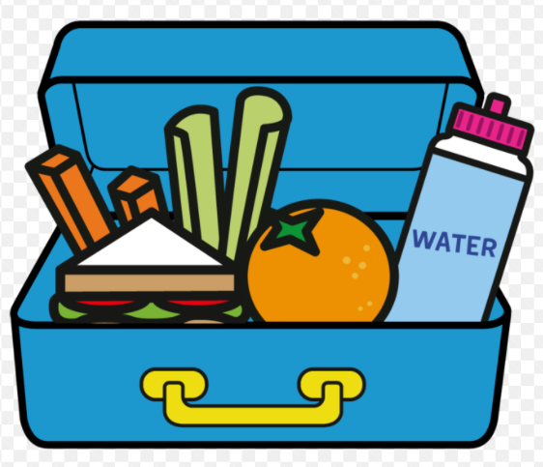

2023

Introduction
This policy was drafted by the School Principal in consultation with the staff of St Patrick’s NS. This policy is to inform children, parents and teachers of the types of food that rea allowed/not allowed in the school. As part of the Social, Personal and Health Education (SPHE) programme, we encourage the children to become more aware of the need for healthy food in their lives.

Aims
The aims of this policy are to:
- Promote the personal development and well-being of the child
- Promote the health of the child and provide a foundation for healthy living
- To encourage children to eat sensibly so that they can gain maximum benefit from the teaching and learning opportunities provided during the course of the school day.
- To ensure the safety of children with allergies
- To encourage children to experience a wide variety of foods.
- To improve oral/dental health
- To reduce litter and encourage recycling by encouraging the children to be aware, alert and responsive to litter problems.

Objectives
- To enable the child to appreciate the importance of good nutrition for growing and staying healthy.
- To enable the child to accept some personal responsibility for making wise food choices and adopting a healthy, balanced diet.
- To enable parents to make the right choices in helping their children to eat healthily in school.

Apart from the well-known health and dental reasons for healthy lunches, research has shown that poor concentration and hyperactivity in children can be caused by nutritional imbalances. Imbalances in blood sugar levels, caused by eating sweet foods also impair learning and concentration. Lunch is an important meal for school-going children. It should provide one third of their recommended daily allowance of nutrients, without being high in fat, sugar or salt. It should also provide dietary fibre.
Children will normally have two food breaks during the day and will be given 10 minutes at each break to eat their lunch.
The Food Dudes (https://www.fooddudes.ie/) and other initiatives may be implemented at times to help enforce healthy eating habits.
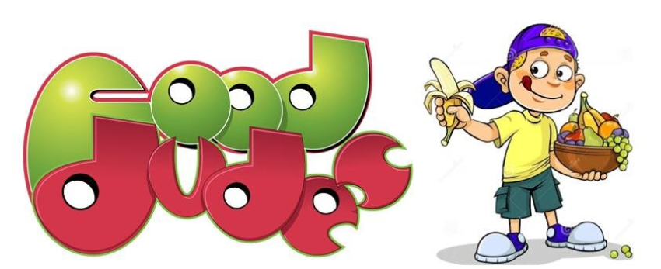

The Food Pyramid
- The food pyramid is a key tool in communication healthy eating messages.
- It is important for children’s energy and concentration levels that they eat a healthy breakfast before coming to school.
- A healthy lunchbox includes pieces from each of the first four shelves of the food pyramid (starting from the bottom).
- Bottom shelf Fruit and Vegetables (vitamin/minerals rich) and the next shelf, Carbohydrates (energy) are especially encouraged to ensure recommended daily portions are met.
- Any foods from the top shelf of the pyramid is not allowed in school.
- Staff will support the healthy eating policy and will not offer sweets to children as rewards or prizes except on special occasions.
- Cakes, buns or treats for birthdays will not be distributed.
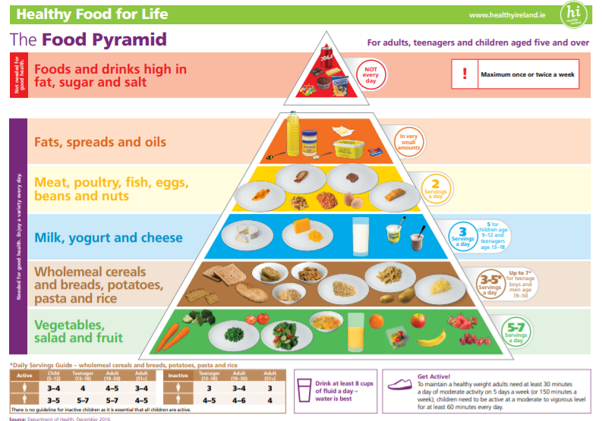

Is my drink tooth friendly?
The following is a guide on the best drinks to give your child to ensure healthy teeth:
 |  | 
Any time | Only at mealtimes | Not tooth friendly
Water  Milk | Unsweetened fruit juice  Diluted sugar-free squash  Yoghurt or milk drinks  Smoothies | Sweetened fruit juice  Fizzy drinks (inc. diet)
Foods and drinks NOT allowed in school:
- Nuts, Nutella or any foods containing nuts or traces of nuts are not allowed under any circumstances. There are pupils in the school who have a nut allergy.
- Kiwi fruit. There are pupils in the school who are allergic.
- Chewing gum is strictly forbidden
- Fizzy drinks/sweetened fruit juices
- Sweets
- Crisps
- Fast food
- Lollipops
- Chocolate products
If your child comes to school with an item that is not allowed in school, he/she will not be allowed to eat this item and it will be returned home in their lunchbox.

Special dietary/Medical requirements
Parents of children with special dietary requirements are required to advise the school of same.

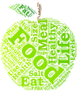Packing the Lunch Box
Children should be able to unwrap and eat their lunches by themselves. Please help by not giving products that they cannot open themselves e.g. food with wrappers, unpeeled oranges etc. To save time, please ensure all food is well prepared (e.g. fruit peeled and chopped if necessary and sandwiches cut).
Parents must ensure that lunch boxes contain whatever utensils are required (no knives).
As we are trying to reduce the amount of waste in the school, parents are encouraged to reduce the amount of packaging in their child’s lunchbox and use reusable containers where possible.
Tips and hints:
- Keep lunches in fridge if prepared the night before
- Use a small insulated cool bag, especially in warmer months
- Cut sandwiches into small manageable pieces, especially for infants
- Peel/cut fruit for younger children
- Avoid foods that children cannot eat without help
- Make lunches as varied as possible.
- Vary the types of bread in sandwiches (wholemeal, granary, high fibre rolls, bagels, pitta etc.)
- Encourage your child to bring their rubbish home in their lunchbox and this will inform you what they have eaten.
- Use refillable drink container – no glass bottles or cartons
- Lunchboxes that they can easily open themselves
Below is a list of possible foods you could pack for your child’s lunch. The lost is not exhaustive and only mentions samples of appropriate foods for the lunchbox.
Bread & Alternatives | Fruit & Vegetables
- Bread or rolls (preferably 100 %wholemeal)  - Pitta bread (preferably 100 %wholemeal)  - Wraps (preferably 100 %wholemeal)  - Crackers  - Rice salad  - Wholemeal scones  - Rice cakes (no chocolate) - multigrain  - Corn cakes, Ryvita, Oat cakes | - Apple, banana, peach, pear  - Mandarins & oranges  - Carrot, pepper, celery sticks  - Cucumber sticks  - Melon slices  - Pineapple cubes  - Grapes  - Sweetcorn  - Tomatoes  - Dried apple, mango pieces  - Blueberries, raspberries
Savouries | Drinks
- Lean meat - Chicken/turkey/ham  - Cheese  - Quiche  - Olives (no stones)  - Hummus  - Guacamole | - Water  - Milk

Drinking plenty of water
Water is essential for life. Through perspiration (sweating), the body uses water to lower body temperature when it is warm. Regular drinks are necessary to replace fluids lost during the day. Without enough water or fluid in the short-term, the dehydration that results can causes tiredness. Water if a tooth-friendly drink. The more active a person is, the more fluid is needed to replace fluid lost as sweat. In hot weather, is playing sports, children should bring extra water to school.
Resources available:
HSE – https://www.hse.ie/eng/about/who/healthwellbeing/our-priority-programmes/heal/healthy-eating-guidelines
Safe Food - https://www.safefood.net/healthy-eating
EU School Milk Scheme - www.moocrew.ie/lunchboxtips

Roles and Responsibility

Each teacher will co-ordinate the progress of this policy and can encourage the children to bring healthy lunches but the responsibility for ensuring that children eat healthily lies with the parent/guardian of each child.

Review

The success of this policy will be judged on the lunches children are bringing to school and becoming aware of healthy/unhealthy foods and drinks. This policy will be reviewed in 2026 with staff.

Communication and Ratification

The policy has been reviewed by staff and ratified by the Board of Management. It will be made available on the school website for parents and a copy has been made available to staff.
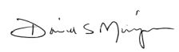
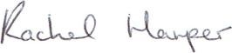

Signed: _________________________ Signed: __________________________
Canon David Mungavin Ms Rachel Harper
Chairperson of the Board of Management Principal

Date: _11/01/2024________________ Date: __11/01/2024_______________

